1.1Create crl and cert directory to host CRLs and certificate



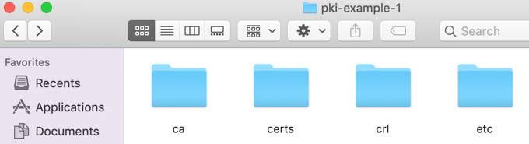

1.2Create folders for Db and Key for root ca

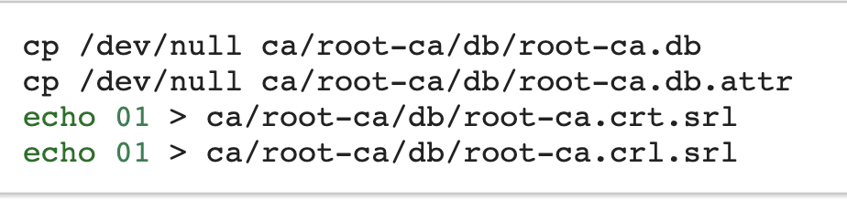

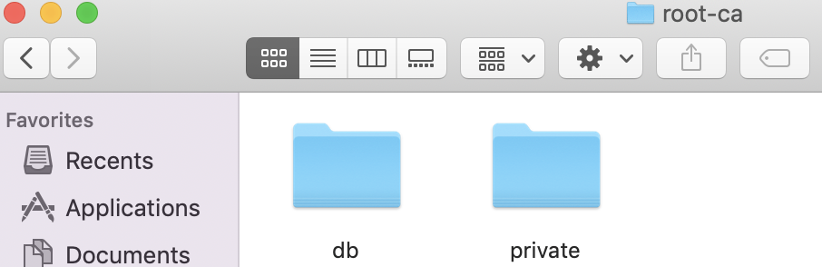

1.3Create a CA request and private key and save to the folder we just create

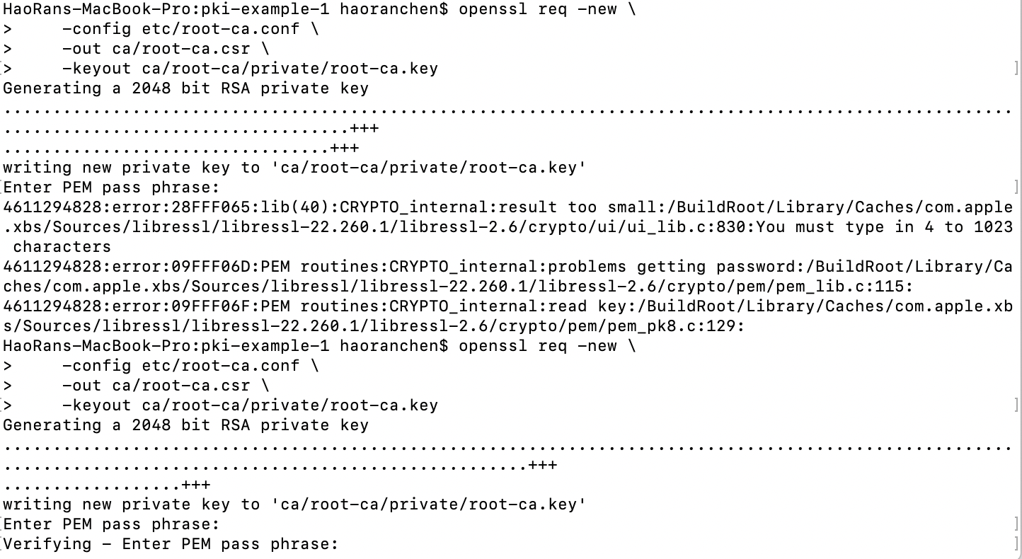

1.4CA create certificate for self, and update the DB

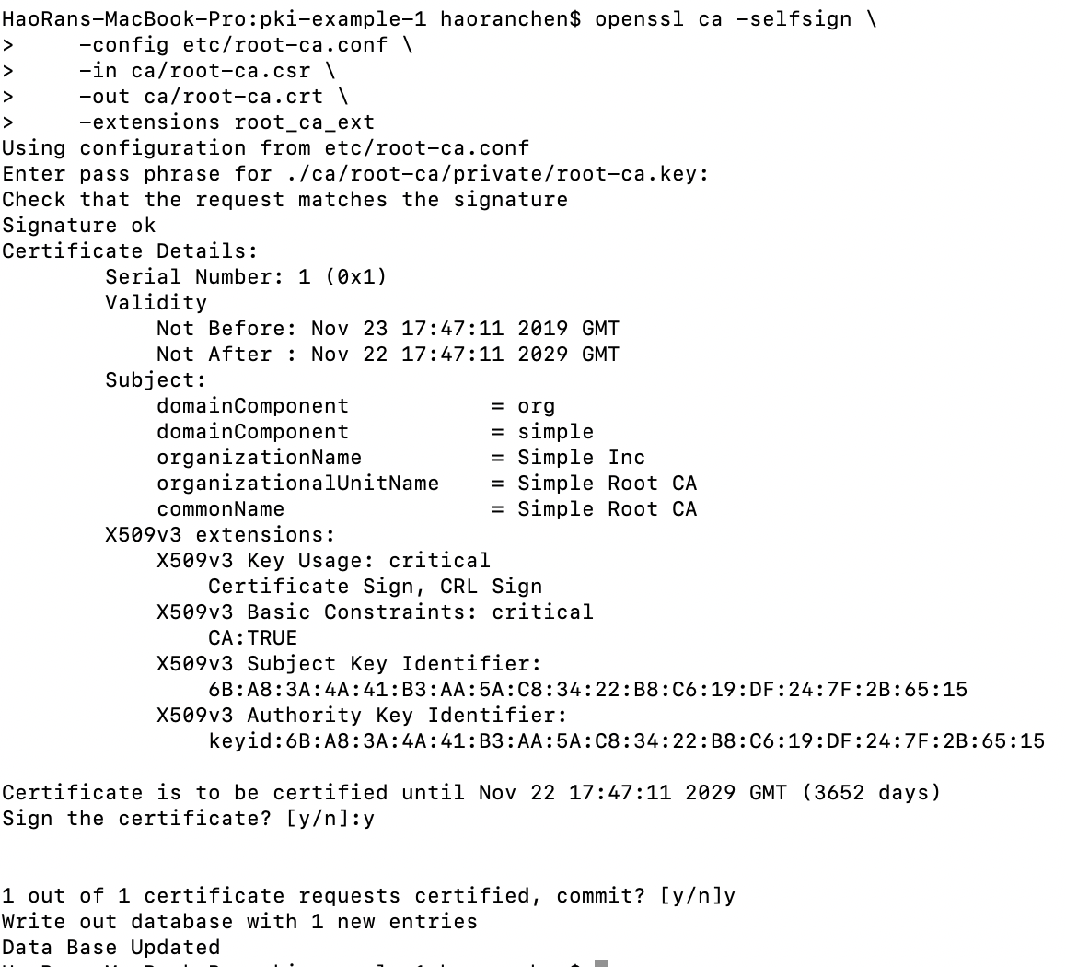

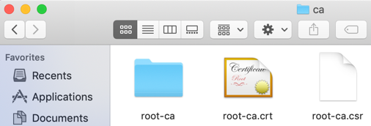

2.1Create siging CA(same as root CA)



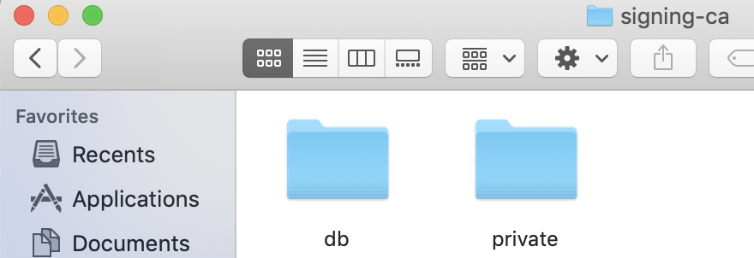

2.2Create DB

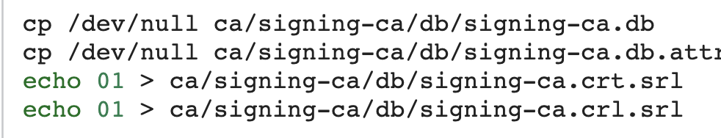

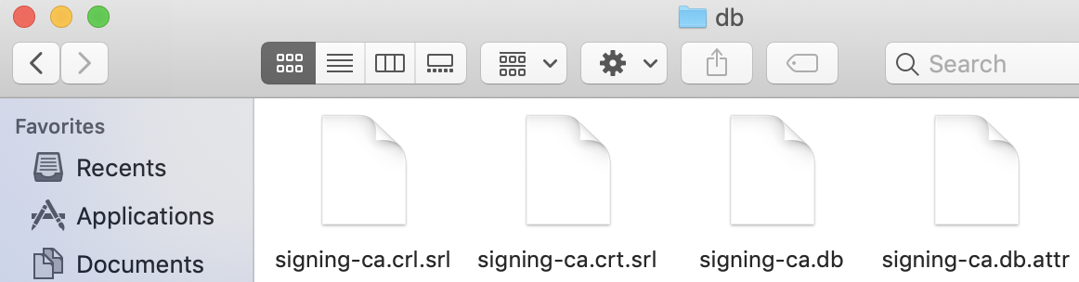

2.3 Create Siginging CA request

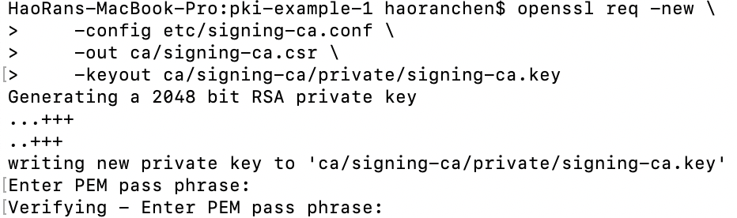

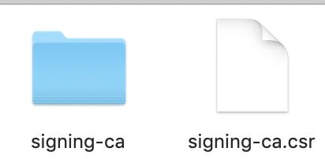

2.4Signing CA get certificate from root ca by using RootCA private key

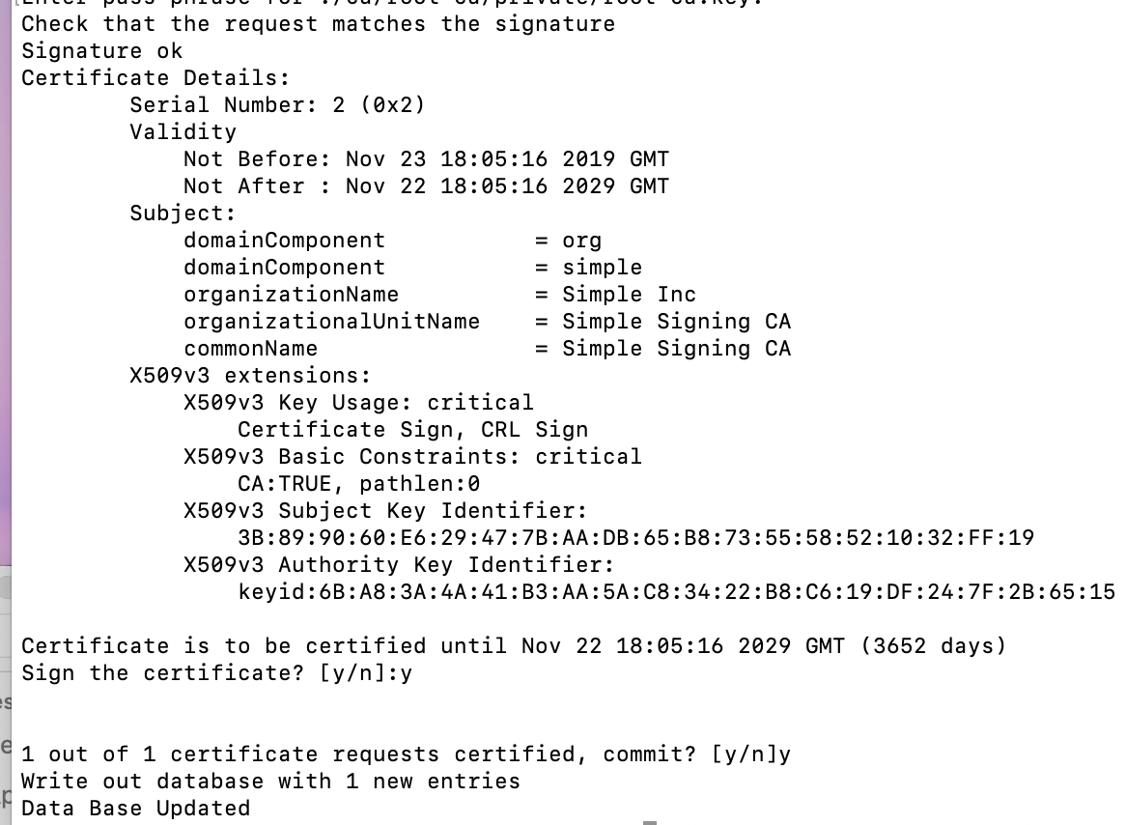

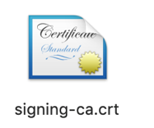

3.Operating Signing CA

3.1 Creating email request

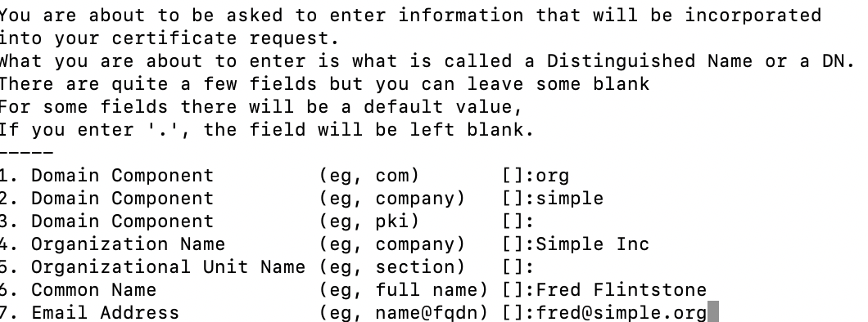

3.2 Create Email Certificate Issued by Signing CA

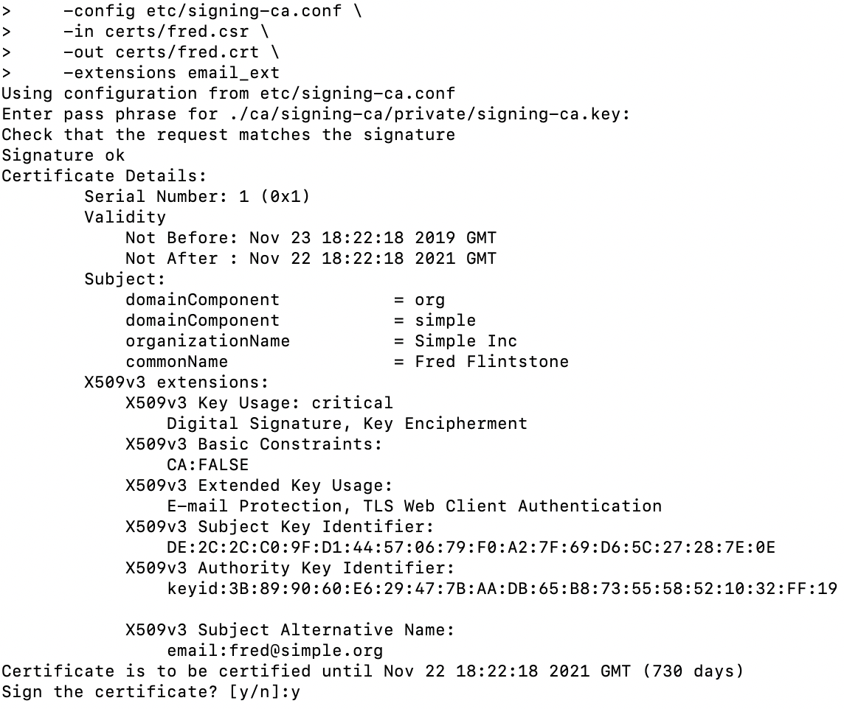

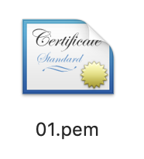

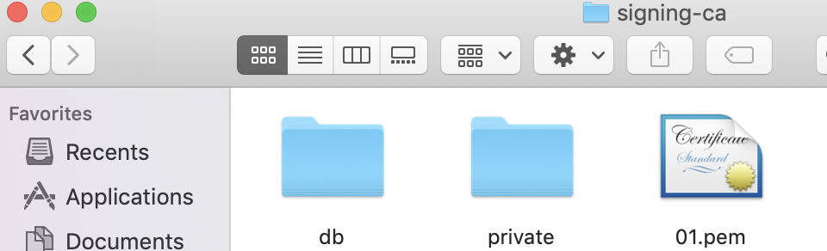

3.3 Create TLS server request

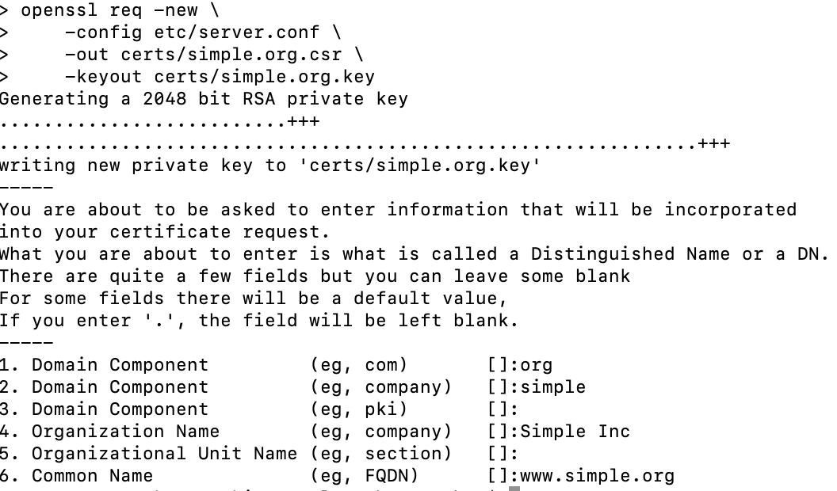

3.4Create TLS server certificate

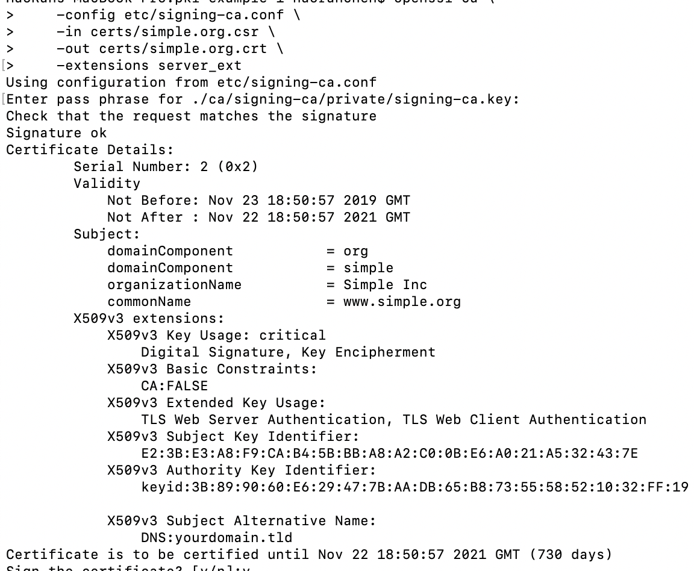

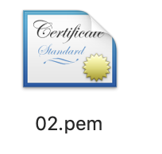

3.5 Revoke Certificate

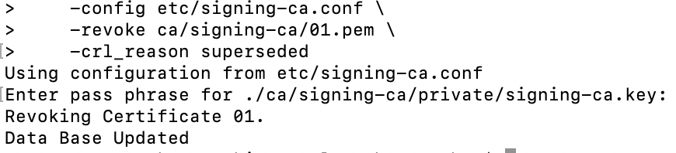

3.6Create CRL, which will create a list of revoked cerificates

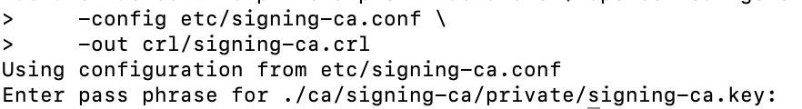

4.Out put Formats

4.1Create DER certificate

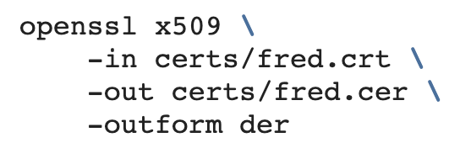

All published certificates must be in DER format [[**RFC 2585#section-3**](https://tools.ietf.org/html/rfc2585.html#section-3)]

4.2Create DER CRL

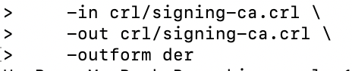

4.3 Create PKCS#7 bundle

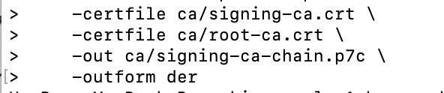

PKCS#7 is used to bundle two or more certificates.

4.4 Create PKCS#12 bundle

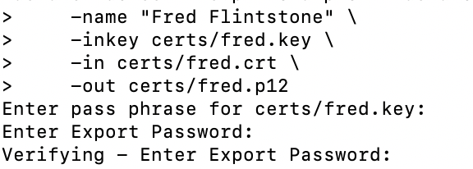

PKCS#12 is used to bundle a certificate and its private key. Additional certificates may be added, typically the certificates comprising the chain up to the Root CA

4.5Create PEM bundle

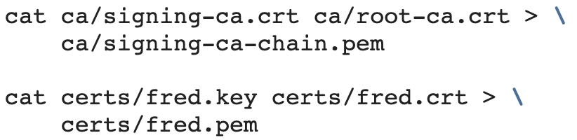

5. View Results

5.1 View request

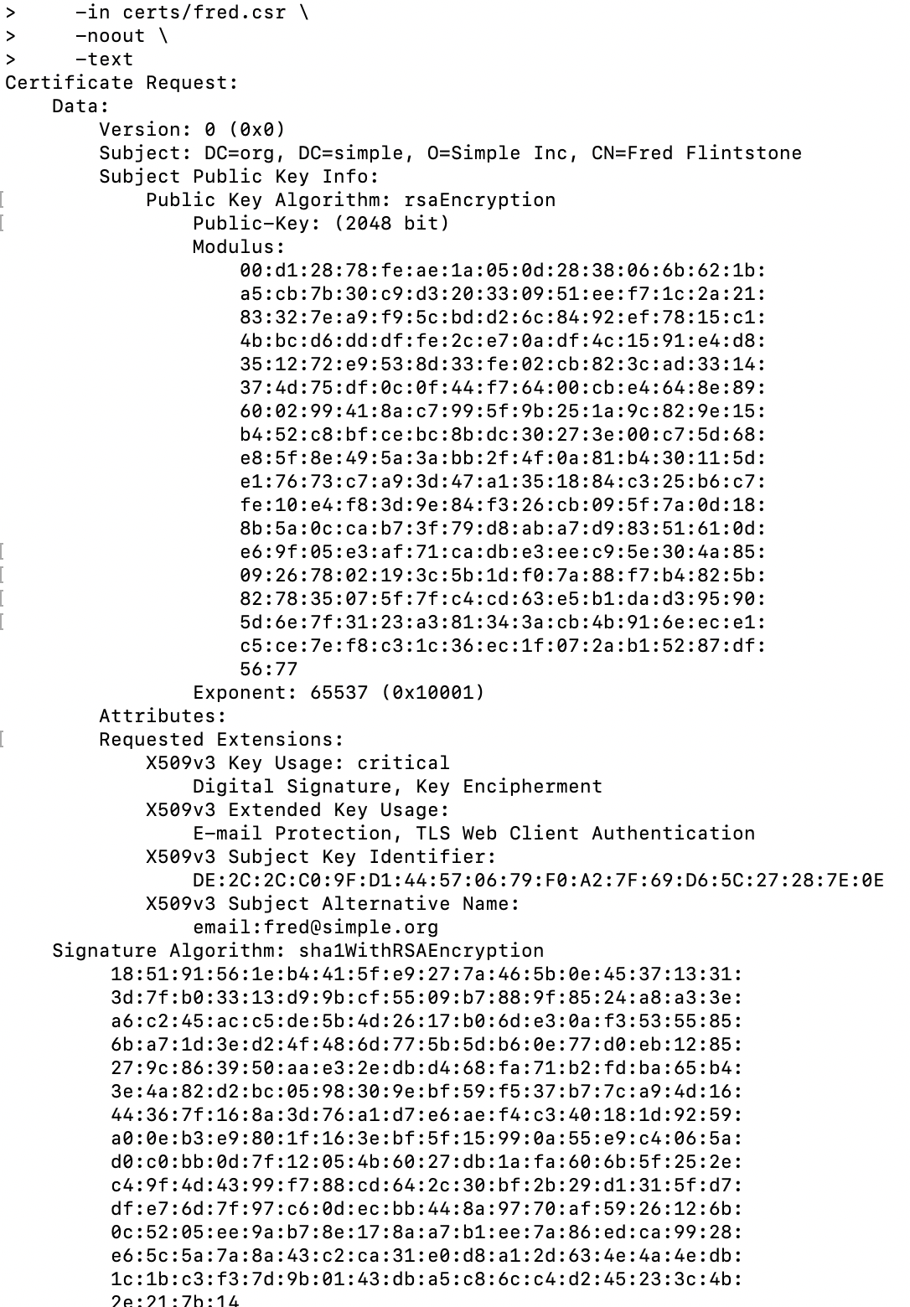

5.2 View Certificate

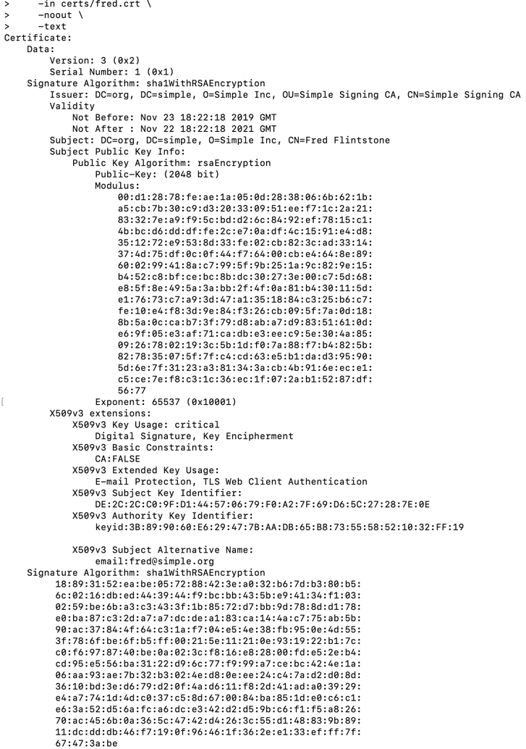

5.3 View CRL

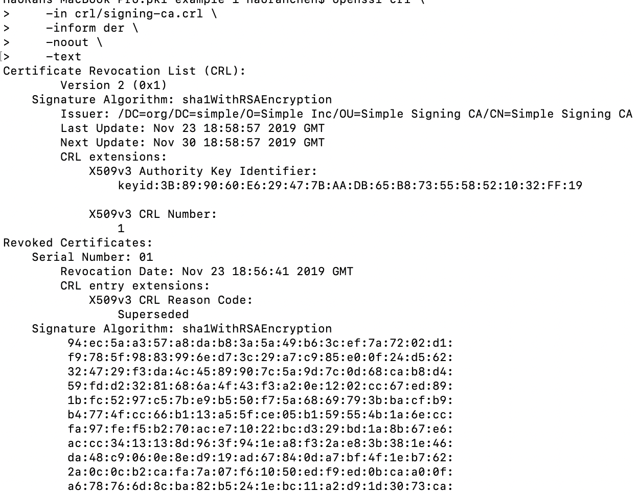

5.4 View PKCS#7 bundle

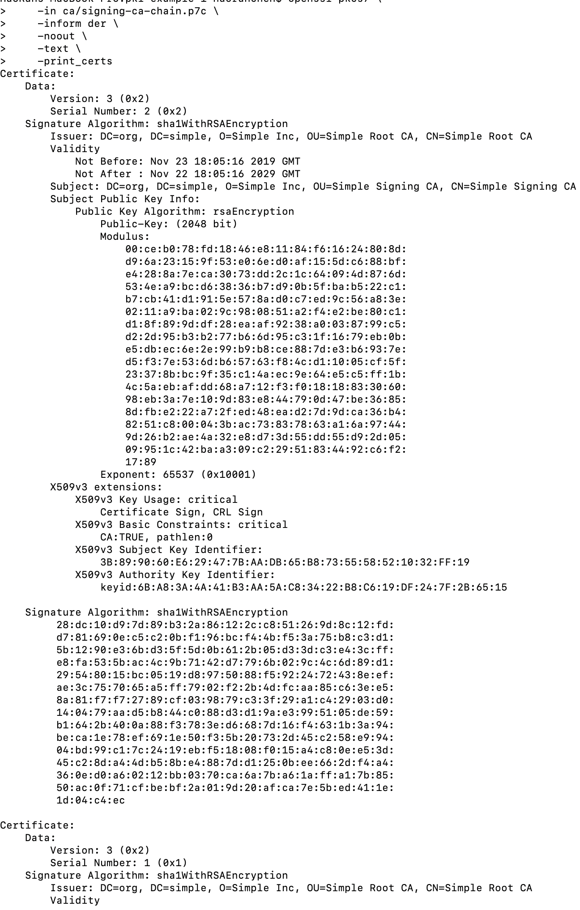

5.5 View PKCS#12 bundle

